**Decision Tree**

***Information Gain***

• We want to determine which attribute in a given set of training feature vectors is most useful for discriminating between the classes to be learned.

• Information gain tells us how important a given attribute of the feature vectors is.

• We will use it to decide the ordering of attributes in the nodes of a decision tree.

***Impurity/Entropy***

– Measures the level of impurity in a group of examples

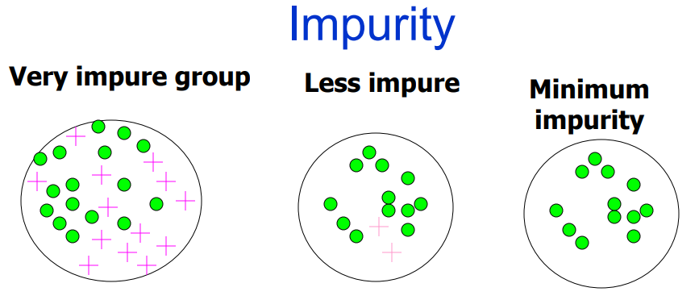

$Information Gain=I \left(p,n\right)= \frac{-p}{p+n} \log_{2}\left(\frac{p}{p+n}\right)- \frac{n}{p+n} \log_{2}(\frac{n}{p+n})$. . . . . . . (1)

$Entropy E\left(A\right)= \sum_{I=1}^{V}{\frac{p_{i} + n_{i}}{p + n} (I(p_{i},n_{i}))}$. . . . . . . (2)

$Gain \left(A\right)=I\left(p,n\right)-E(A)$. . . . . . . . (3)

**Table - T**

|  |  |  |  |  |  |
| --- | --- | --- | --- | --- | --- |
| **Day** | **Outlook** | **Temperature** | **Humidity** | **Wind** | **Play** |
| 1 | Sunny | Hot | High | Weak | No |
| 2 | Sunny | Hot | High | Strong | No |
| 3 | Overcast | Hot | High | Weak | Yes |
| 4 | Rain | Mild | High | Weak | Yes |
| 5 | Rain | Cool | Normal | Weak | Yes |
| 6 | Rain | Cool | Normal | Strong | No |
| 7 | Overcast | Cool | Normal | Strong | Yes |
| 8 | Sunny | Mild | High | Weak | No |
| 9 | Sunny | Cool | Normal | Weak | Yes |
| 10 | Rain | Mild | Normal | Weak | Yes |
| 11 | Sunny | Mild | Normal | Strong | Yes |
| 12 | Overcast | Mild | High | Strong | Yes |
| 13 | Overcast | Hot | Normal | Weak | Yes |
| 14 | Rain | Mild | High | Strong | No |

**Test rows:**

|  |  |  |  |  |  |
| --- | --- | --- | --- | --- | --- |
| **Rows** | **Outlook** | **Temperature** | **Humidity** | **Wind** | **Play** |
| 1 | Sunny | Mild | Normal | Weak | Yes |
| 2 | Rain | Hot | High | Strong | No |

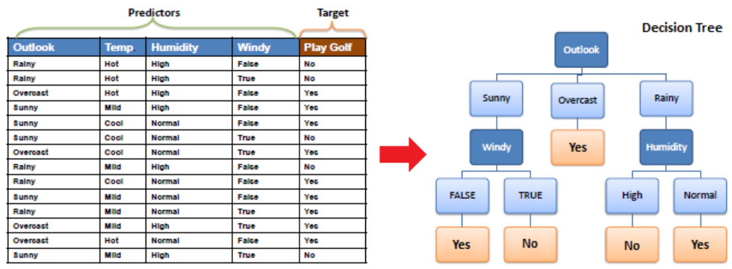Using this table, we shall find the Information Gain at first. And we shall calculate the Entropy

**Decision Tree:** Decision tree is the most powerful and popular tool for classification and prediction. A Decision tree is a flowchart like tree structure, where each internal node denotes a test on an attribute, each branch represents an outcome of the test, and each leaf node (terminal node) holds a class label.

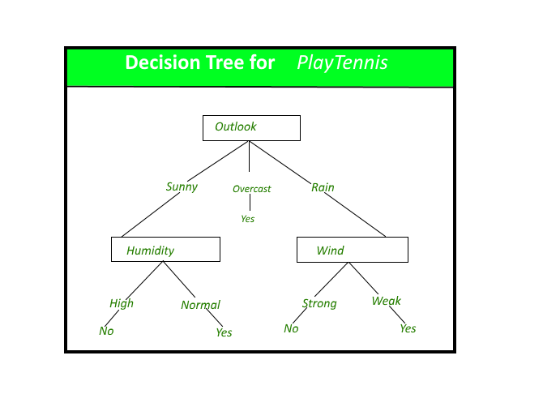

*A decision tree for the concept Play Tennis.*

**Construction of Decision Tree:**  
A tree can be *“learned”* by splitting the source set into subsets based on an attribute value test. This process is repeated on each derived subset in a recursive manner called*recursive partitioning*. The recursion is completed when the subset at a node all has the same value of the target variable, or when splitting no longer adds value to the predictions. The construction of decision tree classifier does not require any domain knowledge or parameter setting, and therefore is appropriate for exploratory knowledge discovery. Decision trees can handle high dimensional data. In general decision tree classifier has good accuracy. Decision tree induction is a typical inductive approach to learn knowledge on classification.

**Decision Tree Representation:**  
Decision trees classify instances by sorting them down the tree from the root to some leaf node, which provides the classification of the instance. An instance is classified by starting at the root node of the tree, testing the attribute specified by this node, then moving down the tree branch corresponding to the value of the attribute as shown in the above figure. This process is then repeated for the subtree rooted at the new node.